Jenkins Assignment -4

Job -1
Repo_1:
Url: https://github.com/anmol2026git/Repo_1.git

Shell script:
cd /var/www/html
rm -rf *
cd
cd /root/.jenkins/workspace/Jenkins-Assignment-4-Job-1
cp -r index.html /var/www/html
cd /var/www/html
chmod 644 index.html
service httpd start
Job -2
Repo_2:

Url: https://github.com/anmol2026git/Repo_2.git

Shell script:
cd /var/www/html
rm -rf *
cd
cd /root/.jenkins/workspace/Jenkins-Assignment-4-Job-2
cp -r index.html /var/www/html
cd /var/www/html
chmod 644 index.html
service httpd startJob -3

Repo_3:

Url: https://github.com/anmol2026git/Repo_3.git

Shell script:

cd /var/www/html
rm -rf *
cd
cd /root/.jenkins/workspace/Jenkins-Assignment-4-Job-3
cp -r index.html /var/www/html
cd /var/www/html
chmod 644 index.html
service httpd start

Accessing the Website
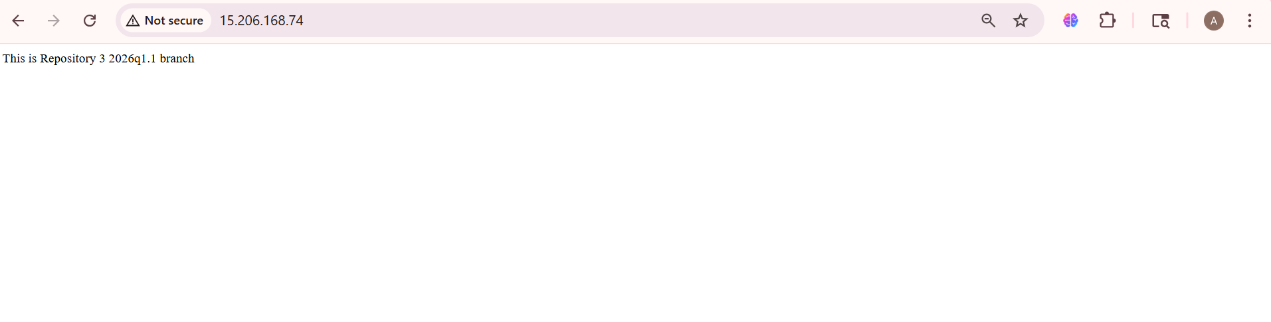
Updated in Repo -1 & Commit
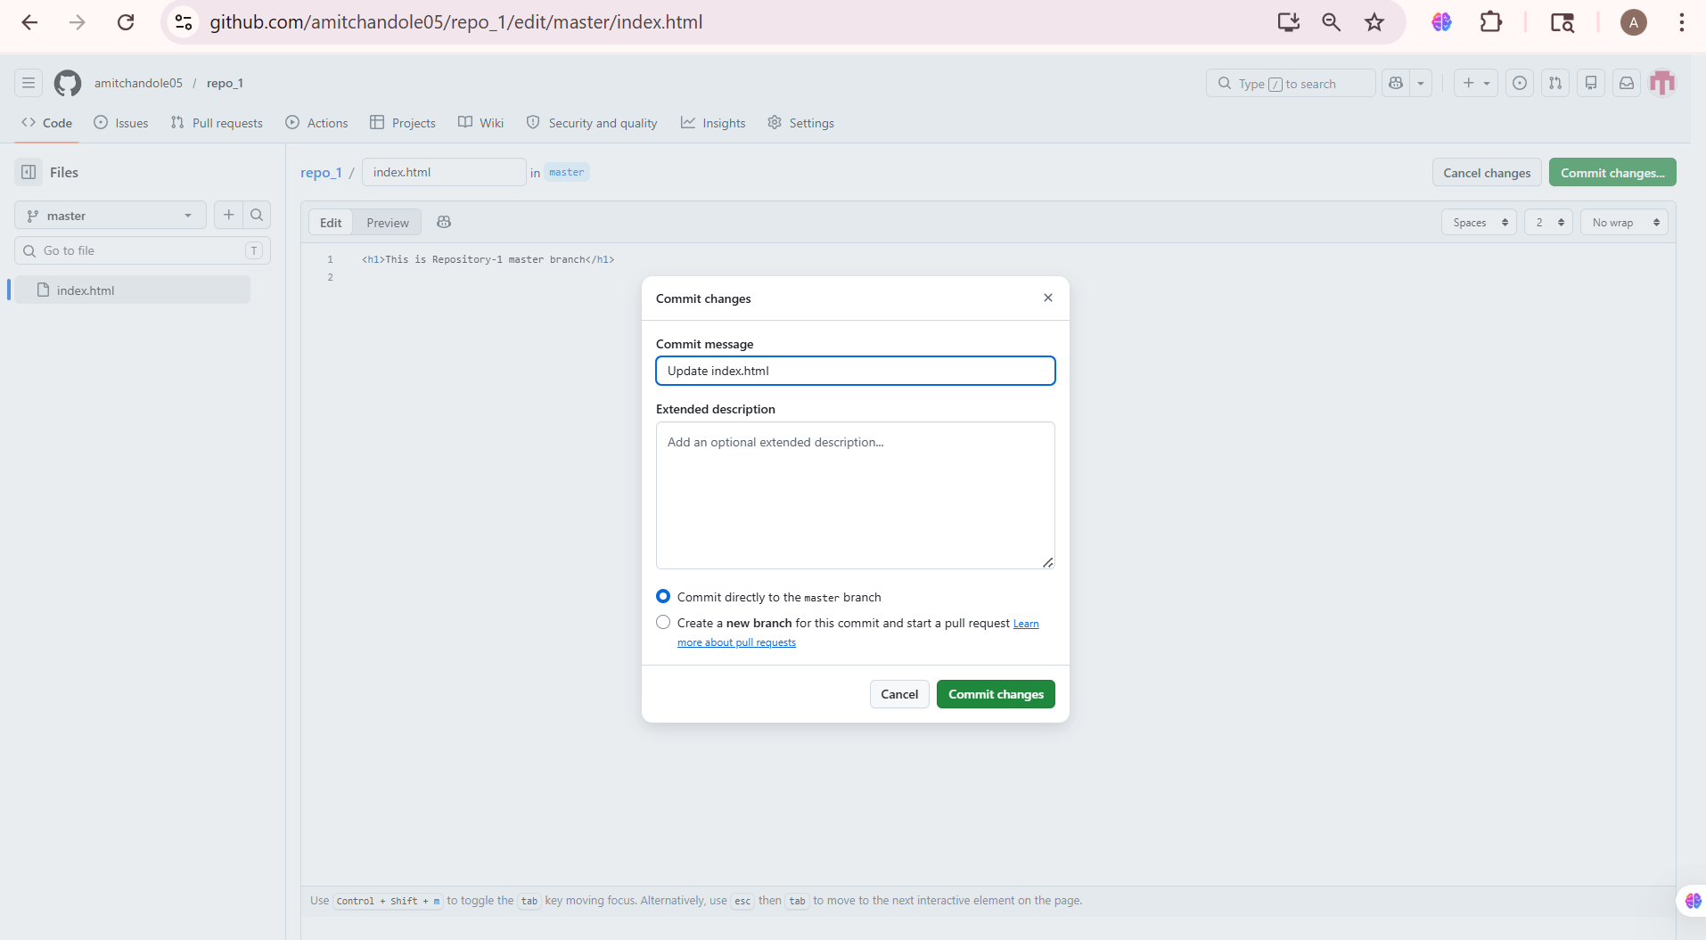
Override the previously Index.html file with new
